**Topic:**

“Supports the team by teaching and advising them, and performing work outside of team meetings.”

**Evidence of “**Supports the team by teaching and advising them…”**:**

Here I’m teaching my team about HTTP Communication in one of our weekly meetings.

<https://youtu.be/n3vyBJIvi4g?t=9m30s>

Here I’m explaining to my team how the meetings should work.

<https://youtu.be/n3vyBJIvi4g?t=31m45s>

Here I’m explaining to Jonathan how to add collaborators to our team GitHub account.

<https://youtu.be/TREfps6ibzg?t=1m5s>

Here I’m showing the rest of my team how to use HTTP Communication**.**

<https://youtu.be/TREfps6ibzg?t=13m55s>

Here I’m teaching my team about Safe Parallel Processing.

<https://youtu.be/oFND1NeVr_U?t=4m57s>

Here I’m teaching my team a little about Hibernate.

<https://youtu.be/zTe_GwzmEBU?t=36s>

I also showed our team how to create a Use Case, Sequence, and State Diagram for our team project though I guess we had stopped recording before I start showing them so I don’t have a video to prove this. I do however have some pictures of our diagram and you can ask Lehi or Austin and they’ll vouch for me.

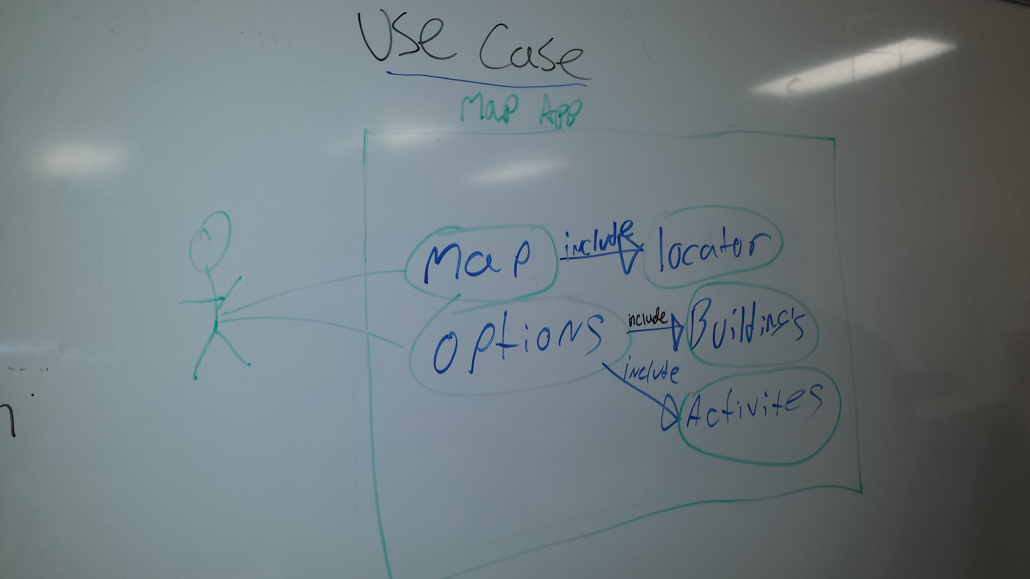

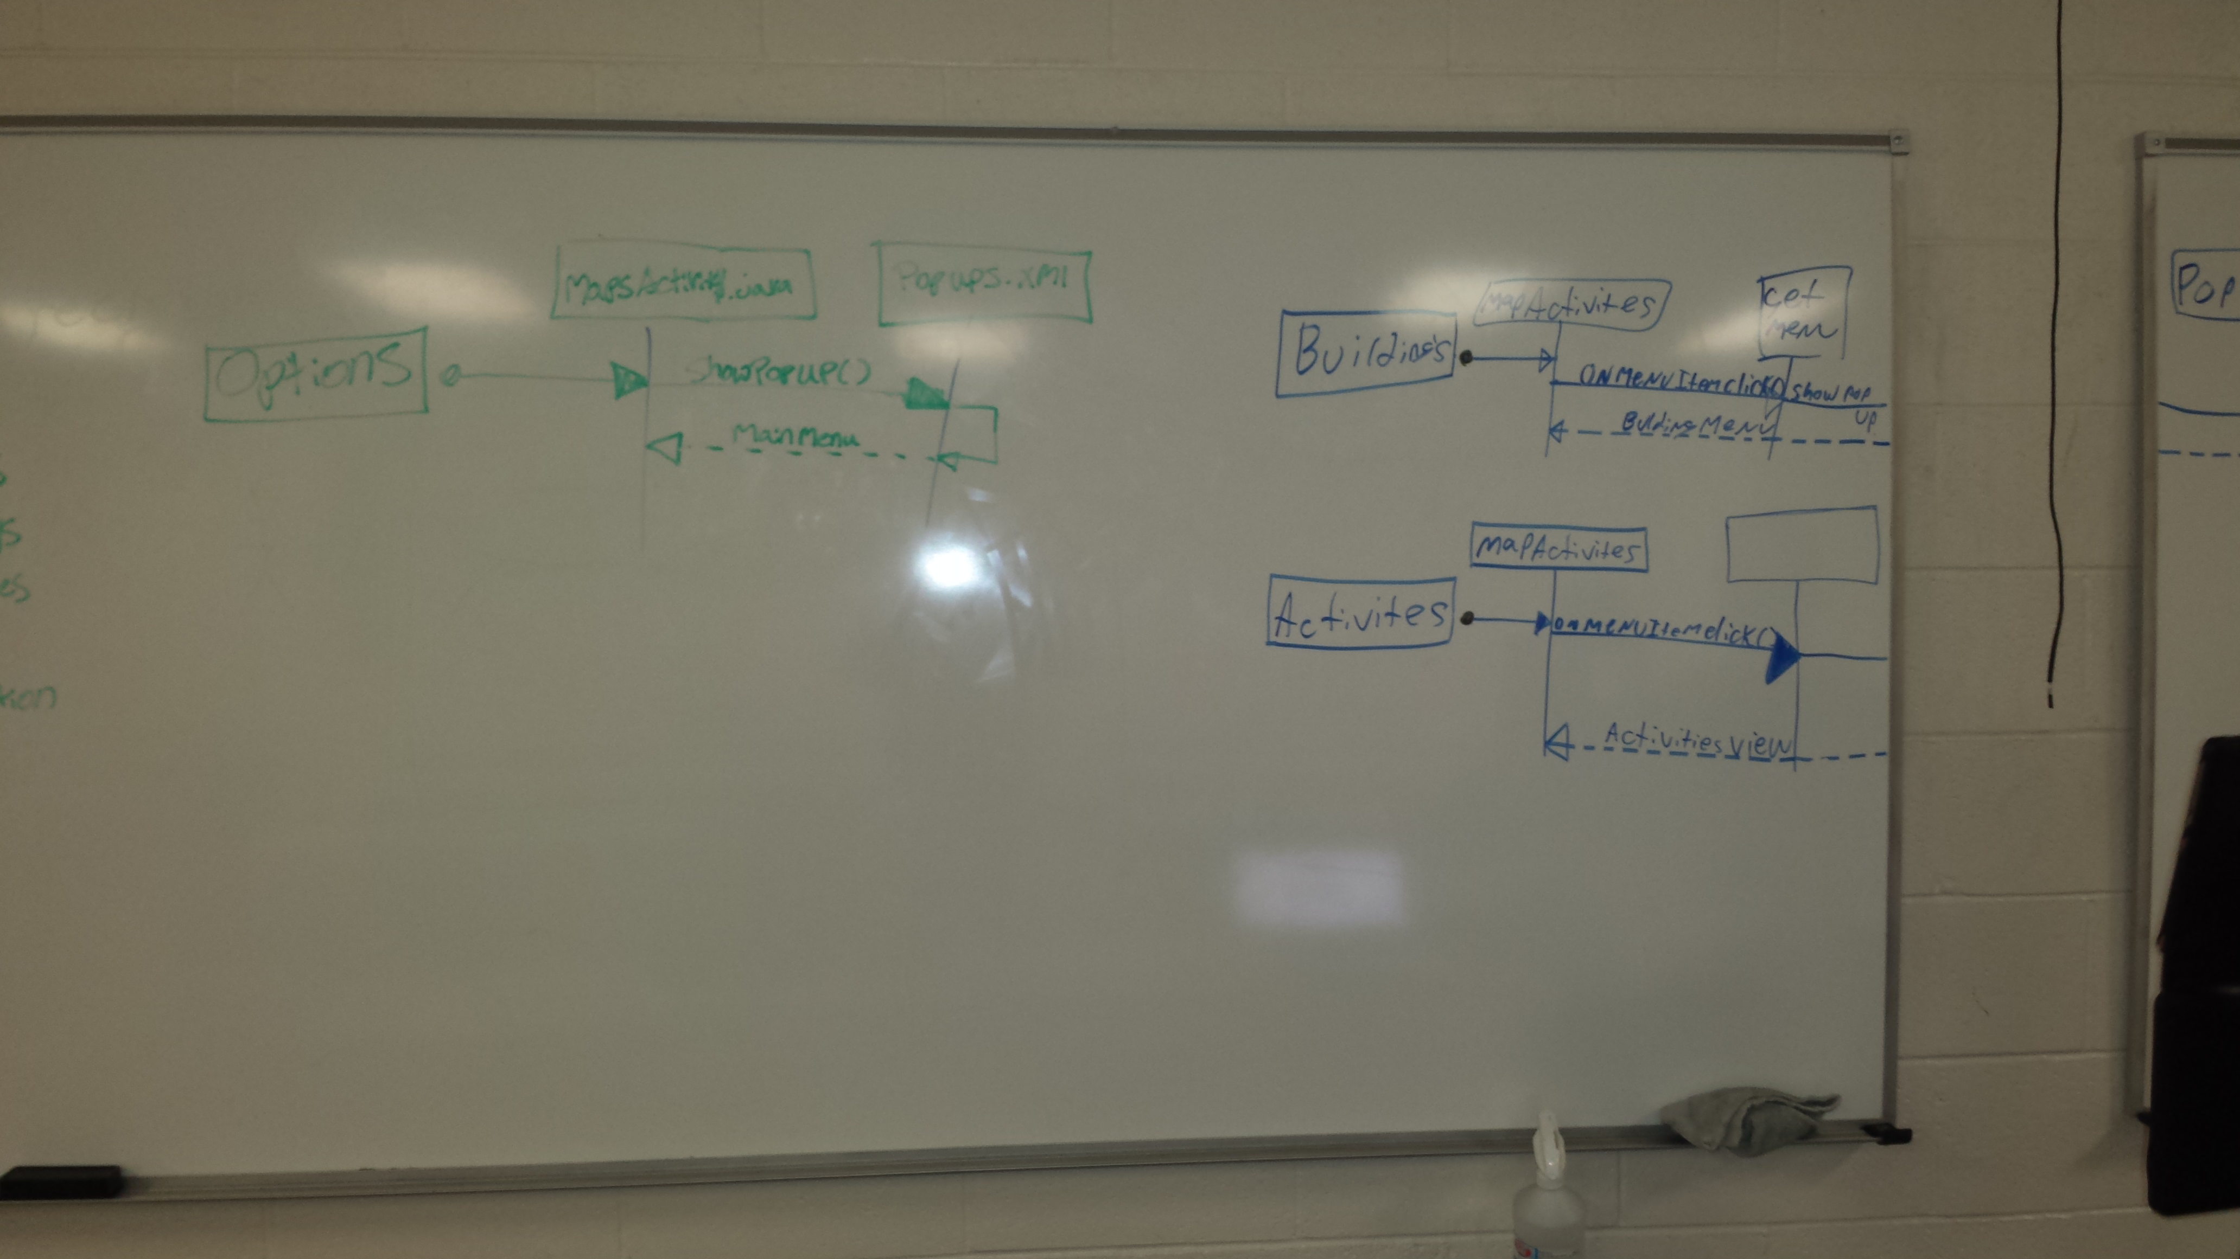

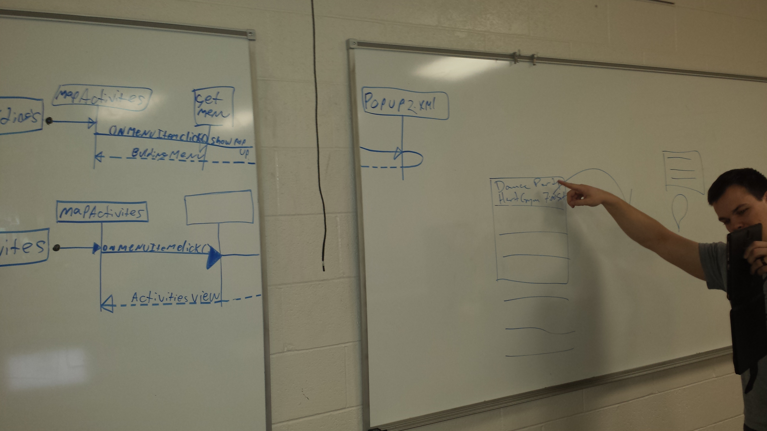

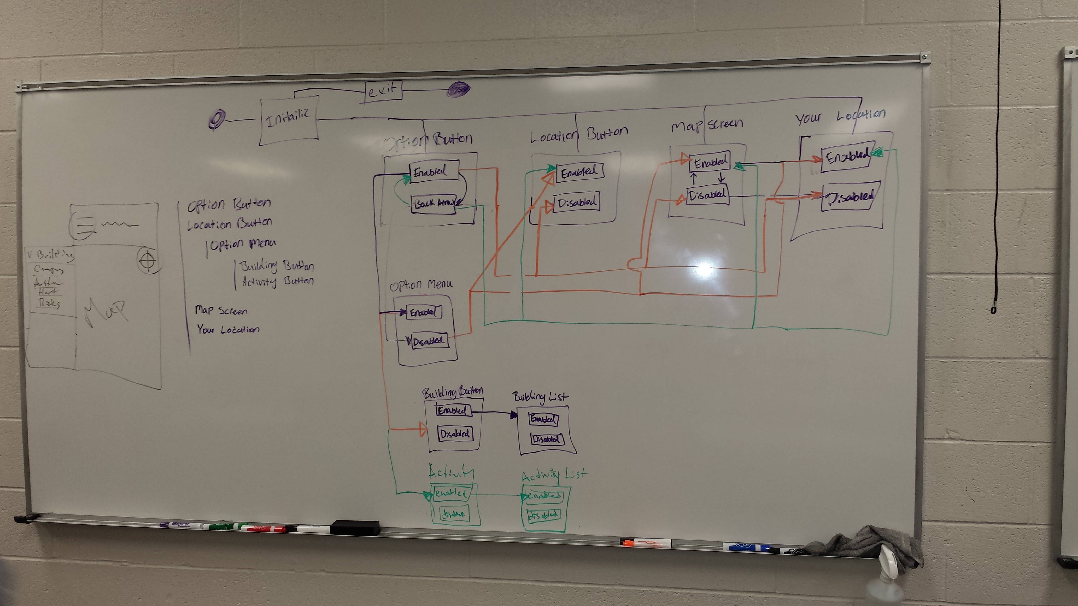

**Evidence of “**…performing work outside of team meetings.” **:**

I’m not sure how to show all the work I did outside of our team meetings, but I did find this little clip in one of our meetings that indicates that I’ve been working outside of our meetings. Hopefully that’s enough to count.

Here I take a couple minutes and talk about how I’ve been working on trying to parse an RSS feed for our team project. I did finally get it working after about 8 hours of working on it over the following weekend.

<https://youtu.be/EaaJeKMaHmQ?t=19m5s>

Here is the link to the code I wrote to parse the BYU-I Activities RSS feed to prove the work I did outside of our team meetings to contribute to our project:

<https://github.com/richardhenke/cit360-sandbox/tree/master/Direct%20Evidence%20of%20Professionalism/XML_Parse_Practice>